**FFT Party Builder with Database**

**Use Cases**

Item Lookup

* Show price, descriptions, and stat modifiers for weapons, armour, items etc.
* See which monster to poach, where in the story it is purchasable, and where to find it via treasure hunting
* Display and link to jobs that can equip the items
* Damage calculator which requires physical attack, magic attack, brave/faith, and speed to calculate estimated damage

Job Lookup

* Shows job prerequisites for job (In a tree?)
* Display and link to equip able gear
* Displays table for default job stats and stat growth rate

Ability Lookup

* Lists Primary, reaction, support, and move abilities for job
* Displays ability description, range, AoE, cast time, MP cost, JP needed to learn, triggering action
* Damage calculator which requires physical attack, magic attack, speed, and brave/faith to calculate estimated damage

Monster Lookup

* Lists the abilities for the three monsters in each monster family
* Displays the (physical attack, magic attack?) move, jump, and evasion rate stats for each monster
* Shows the locations of monster and the normal/rare poach item

Party Overview

* Table of existing party members
* Allows male or female generic characters to be added to a list
* Displays job picture, level, estimated HP/MP, Speed, physical attack, magic attack, move, jump, and evade percentage for each member
* Slider for stepping through the "job timeline" for all party members

Party Member Builder

* Choose gender for generic character (May allow unique characters like Ramza and Cloud to be added)
* Choose job, abilities, and items for a specific point in timeline
* Display estimated damage for each ability
* Slider for stepping through the "job timeline" for party member

**Implementation**

Scraper

* Data will be scraped from http://finalfantasy.wikia.com/wiki/Chemist_(Tactics)
* Scraper will be a console application written in C# using Selenium WebDriver 3 and Entity Framework
* Schemas will be created for each table prior to scraping

General

* Server side will be in ASP.NET MVC 5 in C# using Entity Framework (Maybe async operations for speed?)
* Client side will be an SPA written in HTML5, CSS3, Angular.js
* Will look and behave similarly to the game, with menu's appearing and disappearing on a single page
* Party builds will exist in web local storage; will expand to storing in database later
* Scraped data will be stored in MS SQL database with schemas for all objects

Item Lookup

* Data will have to be scraped at these URI's:
* <http://finalfantasy.wikia.com/wiki/List_of_Final_Fantasy_Tactics_weapons>
* <http://finalfantasy.wikia.com/wiki/List_of_Final_Fantasy_Tactics_items>
* <http://finalfantasy.wikia.com/wiki/List_of_Final_Fantasy_Tactics_armor>
* <http://finalfantasy.wikia.com/wiki/List_of_Final_Fantasy_Tactics_accessories>
* Grid with tab views (Like the shopkeeper and the items in game) for all item categories
* Grid will have two-tiered tabs, the top tab for the item category (weapons, armour etc) and bottom tab for item type (Rod, Spear, Clothes, Bombs, etc)
* All items will list jobs that can equip the respective item

* **Weapons**
* Weapon categories include: Axes, Bags, Books, Bows, Cloths, Crossbows, Fell Swords, Flails, Guns, Instruments, Katanas, Knives, Knight Swords, Ninja Blades, Poles, Rods, Polearms, Staves, Swords, Throwing Weapons, Unarmed
* Displays attack power, evade percentage, description, spell effect (if any), status effect (if any), magic attack boost (if any), mode (if any), element (if any), when/where to buy (if any), monster to poach (if any), steal (if any), treasure hunt (if any)
* Damage calculator is shown for each field and requires physical attack, magic attack, brave/faith, and speed
* Damage calculation will be client side using Angular.js
* **Armour**
* Armour categories include: Amour, Clothes, Hair Adornments (Female only/Cloud), Hats, Helmets, Robes, Shields
* Displays HP (Physical evade bonus percentage as number)/MP bonus (Magical evade bonus percentage as number), description, physical attack/magick attack boost (if any), element halves/negates/absorbs/boosts (if any), status effect (if any), status effect immunities (if any), when/where to buy (if any), mode (if any), monster to poach (if any), treasure hunt (if any), steal (if any)

* **Accessory**
* Accessory categories include: Shoes, Armguards, Rings, Armlets, Cloaks, Perfume, Lip Rouge
* Displays physical/magickal evade bonus (if any), description, physical attack/magick attack boost (if any), element halves/negates/absorbs/boosts (if any), status effect (if any), status effect immunities (if any), when/where to buy (if any), mode (if any), female only (if any), monster to poach (if any), treasure hunt (if any), steal (if any)

* **Items**
* Item categories include: Restorative Items, Bombs, Shurikens
* Displays HP/restore (if any), item power (if any), element (if any), status effect removal (if any), when/where to buy (if any), monster to poach (if any)
* If item can be thrown by Ninja, show a damage calculator that requires item power and speed, will be done in Angular.js
* If coming from the item lookup menu, then display all stats for all items
* If coming from the party member builder menu, then display the stats for the respective item slot (If choosing a weapon, only show weapons for that job etc)

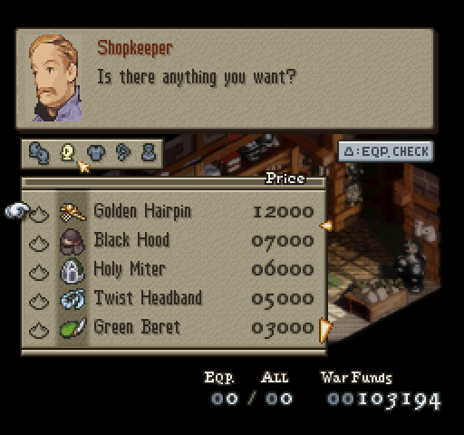

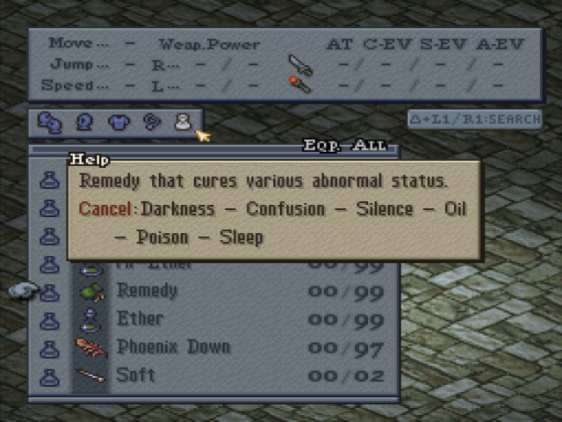

Job Lookup

* Data will have to be scraped here <http://finalfantasy.wikia.com/wiki/List_of_Final_Fantasy_Tactics_jobs>
* Display base attributes (HP/MP, physical attack, magical attack, speed, move, jump, evasion) for job in a table
* Display growth rate for attributes (HP/MP, physical attack, magical attack, speed) for job in a table
* Show calculator for estimating job attributes requiring level and gender
* Display wearable weapon categories and armour categories and if it can wear shields
* Display job abilities (Primary, reaction, support, move)
* Display job prerequisites in tree

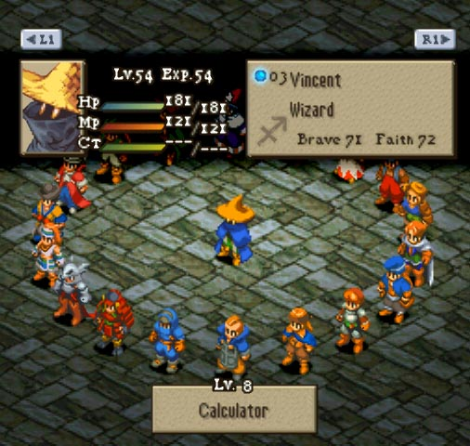

Ability Lookup

* Data will be scraped from each job page ex. <http://finalfantasy.wikia.com/wiki/Dark_Knight_(Tactics)>
* Job abilities will be displayed in grid with single tab view from ability
* Displays ability name, description, HP/MP cost (if any), range, trigger (if any), AoE, charge time, element (if any), JP needed to learn, status effect (if any)
* Display estimated HP/MP damage/restore and success rate requiring physical/magickal attack, brave/faith and speed

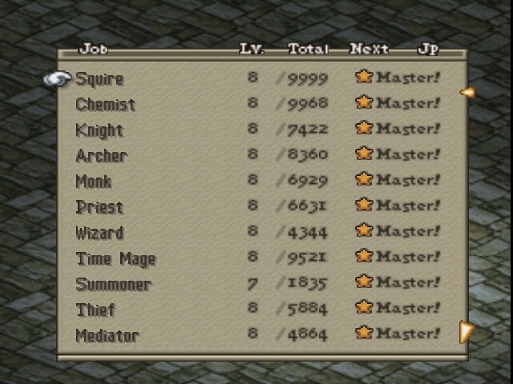

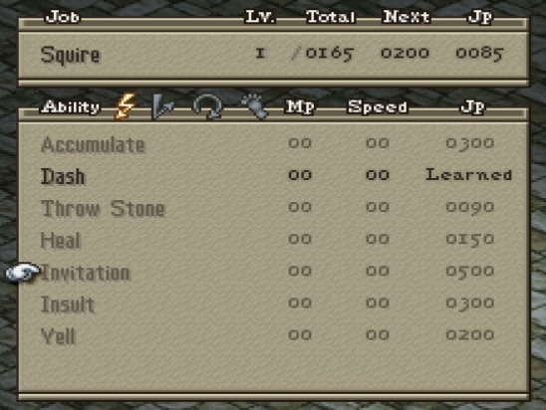

Party Overview

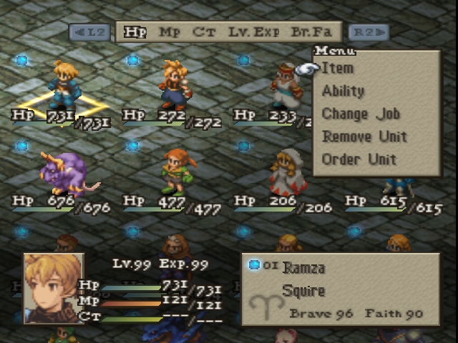

Party Member Builder

